Name:____________________________ Class:_____________ Date:___________
Current Events Report Q2

*Think of a topic that interests you and search for a news article on a story/event to complete the following report on.

*Print and attach the article to this page!

*Use sources such as: cnn.com/studentnews, magazines.scholastic.com, dogonews.com, timeforkids.com, Woonsocket Call Newspaper, Valley Breeze Newspaper, etc.

1.
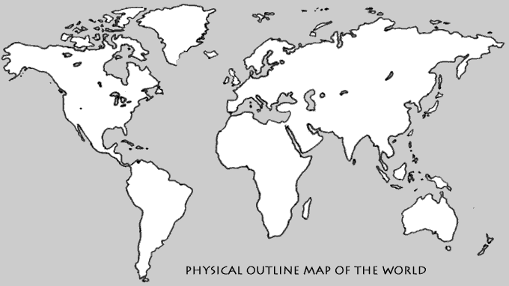 | Put an ‘X’ on the map where the story/event took place  Write the location here:  ________________________________________________

2. Please summarize the article you chose.
Main Idea:
Detail 1:
Detail 2:

3. Please create 3 text dependent questions about the article you chose. (Answers must be found in the text)
a.

b.

c.

4. List 3-5 words from the text you did not know or were confused by.

5. Take one word you did not know and look it up in the dictionary. Write definition below!

6. What do you believe the author thinks about the story/event? Does he/she like or dislike what happened? Can you tell by their writing?

7. Find two details from the text to support your opinion.

a.

b.

8. Draw a short storyboard about the four most important parts of the story/event in the order they appear in the text and include a caption under the picture
1 | 2
3 | 4

9. Create an alternate title for the story/event

